**Registers associated with memory management concept in operating system.**

1. **Base Register**:

- Stores the starting physical address of the process in main memory.

- Used for address translation during dynamic relocation.

- Each logical address generated by the process is added to the value in the base register to derive the corresponding physical address.

2. **Limit Register**:

- Holds the maximum logical address that a process can access.

- Prevents processes from accessing memory outside their allocated space, ensuring memory protection.

- The MMU checks each logical address against the limit register to ensure it's within bounds.

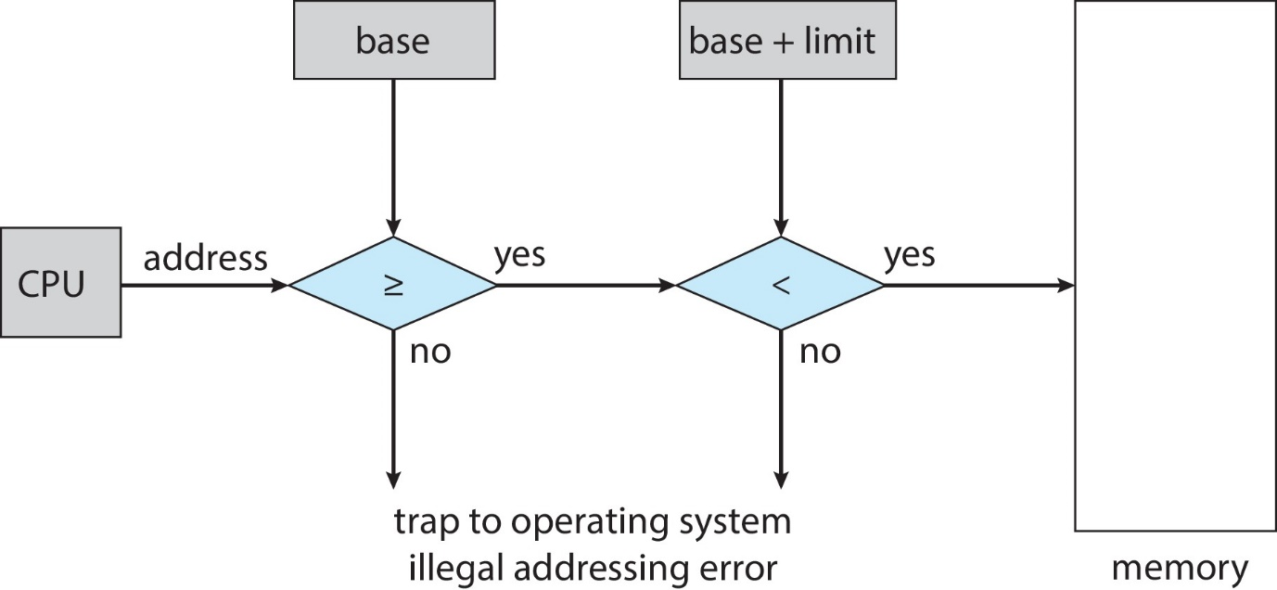

3. **Relocation Register**:

- Similar to the base register, but used specifically for memory protection in fixed-partition allocation schemes.

- Contains the value of the smallest physical address that the process can access.

- Logical addresses are added to the relocation register's value to obtain physical addresses.

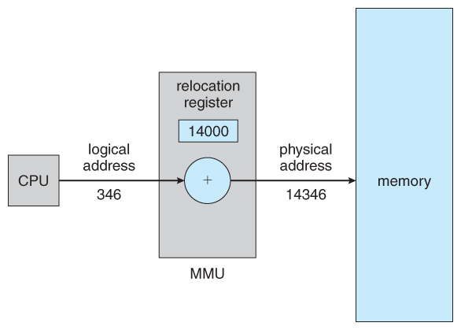

4. **Page Table Base Register (PTBR)**:

- Stores the physical address of the page table for the currently running process in a paging memory management system.

- The MMU uses the PTBR to access the page table, which maps virtual addresses to physical addresses.

5. **Page Number Register (PNR)**:

- Holds the page number of the virtual address that needs translation in a paging system.

- The MMU uses the PNR and PTBR to locate the corresponding page frame number in the page table.

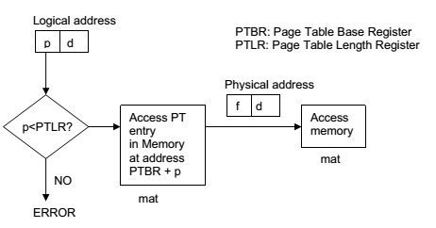

6. **Memory Management Unit (MMU) Registers**:

- Specialized hardware registers within the MMU that control various aspects of memory management, including:

- Translation Lookaside Buffer (TLB): Caches recent virtual-to-physical address translations for faster access.

- Segment Table Register: Stores information about memory segments for segmentation memory management.

- Page Fault Register: Stores information when a page fault occurs, triggering the OS to handle the missing page.

Additional Information:

- These registers work in conjunction with the Memory Management Unit (MMU), a hardware component that handles address translation and memory protection tasks.

- The specific registers used and their implementation details vary depending on the operating system and hardware architecture.